**COP’S FIR Record Management System**

*A*

*Mini Project Report*

*Submitted in partial fulfilment of the*

*Requirements for the award of the Degree of*

**BACHELOR OF ENGINEERING**

IN

**INFORMATION TECHNOLOGY**

By

**M.ROHITH(1602-19-737-089)**

**N.CHARVEE KRISHNA(1602-19-737-078)**



**Department of Information Technology**

**Vasavi College of Engineering (Autonomous)**

**(Affiliated to Osmania University)**

**Ibrahimbagh, Hyderabad-31**

**2020**

**Vasavi College of Engineering (Autonomous)**

**(Affiliated to Osmania University)**

**Hyderabad-500 031**

**Department of Information Technology**



**DECLARATION BY THE CANDIDATE**

We, MIRYALA ROHITH and NANDURI CHARVEE KRISHNA bearing hall ticket numbers, 1602-19-737-089 and 1602-19-737-078 respectively,, hereby declare that the project report entitled **“COP’S FIR Record Mangement System”** Department of Information Technology, Vasavi College of Engineering, Hyderabad, is submitted in partial fulfilment of the requirement for the award of the degree of **Bachelor of Engineering** in **Information Technology**

This is a record of bonafide work carried out by me and the results embodied in this project report have not been submitted to any other university or institute for the award of any other degree or diploma.

MIRYALA ROHITH– 1602-19-737-089

NANDURI CHARVEE KRISHNA – 1602-19-737-078

(Faculty In-Charge) (Head,Dept of IT)

**AKNOWLEDGEMENTS**

The satisfaction that accompanies the successful completion of this project would not be in complete without the mention of the people who made it possible, without whose constant guidance and encouragement would have made efforts go in vain. We consider ourselves privileged to express gratitude and respect towards all those who guided us through the completion of this project.

We thank our faculty (Prasanna mam) because they clarified our few doubts regarding to the project, gave few suggestions and guided us by which we successfully completed our project.

Last but not the least, we wish to thank our parents for financing our studies in this privileged Vasavi College of Engineering as well as for constantly encouraging us to learn engineering. Their personal sacrifice in providing this opportunity to learn engineering is gratefully acknowledged.

Sincerely,

**MIRYALA ROHITH 1602-19-737-089**

**NANDURI CHARVEE KRISHNA 1602-19-737-078**

**ABSTRACT**

As FIRST INFORMATION REPORT(FIR) is the first step which sets for the criminal justice. It is only on the basis of FIR, the police starts investigation.So,our project is based on the idea to maintain all the Fir records of a police station.From this system, the user can easily add each and every convicts details ,with login system which makes data more secure. In order to make it different from the current records in police stations we added a feature of 2-step verification for deleting records.

**Table of contents**

|  |  |
| --- | --- |
| **Topic** | **Page Number** |
| **1.)Introduction** | **6** |
| **2.)Technology** | **8** |
| **3.)Proposed Work**  **3.1 Design**   * + 1. **Use case diagram**     2. **flowcharts**   **3.2 Implementation**   * + 1. **Description of main modules/classes/components.**     2. **Any specific algorithms/logic to be highlighted.**     3. **Github links and folder structure.**   **3.3 Testing** | **9** |
| **4.)Results** | **17-23** |
| **5.)Additional Knowledge Acquired** | **24** |
| **6.)Conclusions and Future work** | **25** |
| **7.)References** | **26** |

## 1.INTRODUCTION

## ABOUT THE PROJECT

“COP’s FIR RECORD MANAGEMENT SYSTEM” is a console-based C-Project which keeps the record of students and staff of the institution. The program is run by the System User who can add, record, modify, delete, and find records according to the need.

**WHAT WE PRIORITIZED**

Cop’s FIR record management system is a Criminal record management system that uses to record crime activities of criminals. It can be used to report crime activities. This project is mainly useful for law and enforcement agencies.The law and enforcement authority can preserve records of the criminals and search any criminal using the system.

So, it is obivious to migrate the whole process in an automated way so that which help the authority and user to maintain all things with ease.

This system is based on a concept to maintain all the Fir records of a police station. From this system, the user can easily add each and every convict’s detail such as convict’s id, name, age, gender, height, weight, crime, face details, conviction etc. Apart from this, the user can view/check a list of the records, search, modify and remove records too.

Login system is also available in this project to make it more secure. Before removing a record, the user has to enter the password again for the access which works as a verification.  There’s no chance of data misuse.Because removing a record is a 2 step verification process.

**OBJECTIVE OF OUR PROJECT**

The Main aim of developing this project is to provide any easy way not only automate all functionalities involved and also to provide full functional reports to COP’s with necessary details. Nowadays large scale organization are committed to bring the best way of management in the various forms.

# 2.TECHNOLOGY

All computer software needs certain hardware components or other software resources to be present, in order for computers to be used efficiently. These prerequisites are known as System Requirements. Within this, we have two types – Software Requirements and Hardware Requirements.

## SOFTWARE REQUIREMENTS

Software Requirements deal with defining the software resource requirements and prerequisites that need to be installed on a computer to provide optimal functioning of an application. These preconditions are generally not included in the software installation package and need to be installed separately.

In order to use COP’S FIR Management System, one should have the following:

* **Operating System:** Windows 7 and above
* **C Compiler:** GNU Compiler Collection (GCC)
* **Editor:** Any text editor .(Vim Editor)

## HARDWARE REQUIREMENTS

Hardware requirements refer to the common set requirements defined by any operating system or software application and are usually the physical computer resources. In this, we look into the architecture, processing power, memory, secondary memory, display adapter and peripherals.

In order to use this project, one should have the following:

* + - **Processor:** Intel i5 processor and above
    - **Memory:** 4 GB RAM and above

**3.PROPOSED WORK**

**3.1 DESIGN**

Our approach in designing the COP’S FIR management system is to reduce the pen and paper work to manage the records in any legal Institution (Police Station).

**i.)USE CASES**

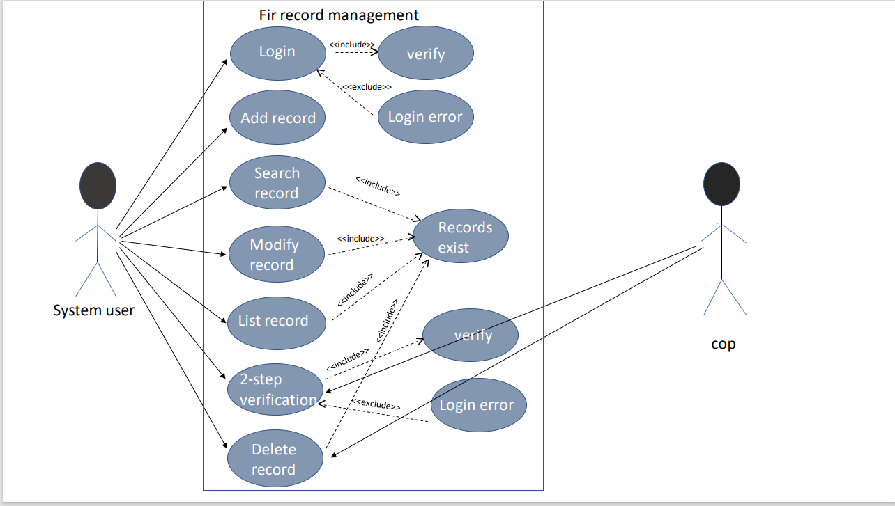

**ii.) Flow Chart**

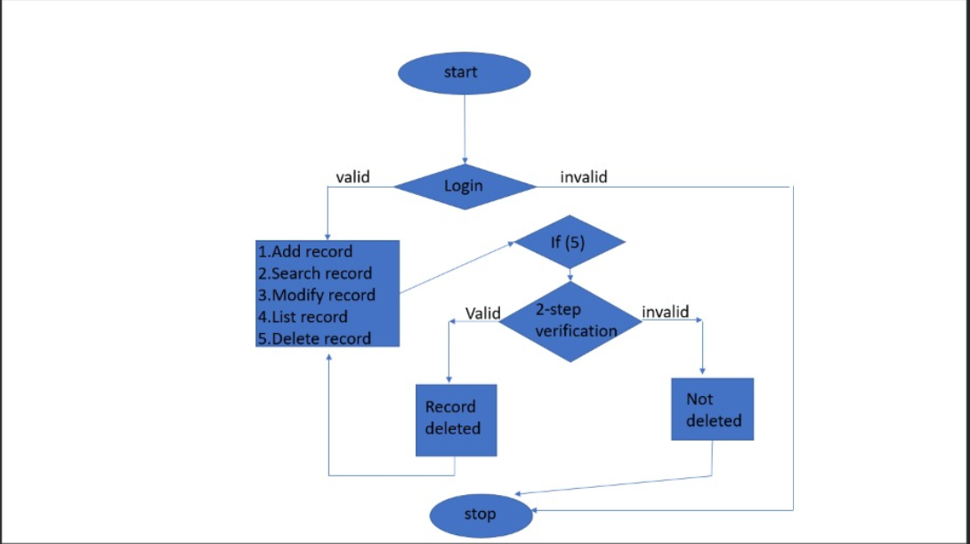

3.2 IMPLEMENTATION

Based on the use cases, we have implemented this project by dividing the work into modules – Start, Login, Add Record, Search Record, Modify Record, Delete Record, and Exit is to terminate the application.

**i.)Description of main modules/classes/components**

**3.2.1 LOGIN**

The System user have to login with the predefined username and password. If the password and username are attempted incorrectly for thrice the it will exit. If the credentials were correct the System user get the access to COP’S FIR Management System Environment.

**3.2.2 ADD RECORDS**

The System user can add the records of the criminals/convict. The System user can add the details of criminals/convict, like name, id,crime done by criminal,conviction e.t.c.

**3.2.3 SEARCH RECORDS**

The System user can search the details of the criminals/convict by providing the details like id ,name of the criminal. If there records doesn’t exist it does not show any details on the screen. If the records exist it displays the details.

**3.2.4 MODIFY RECORDS**

The System user can modify the details of criminals/convict like name,date of arrest e.t.c. If and only if the records exist. Otherwise it gives error.

**3.2.5 DELETE RECORDS**

The System user can delete the records of criminals/convict based on the requirements and to delete a record we must know the predefined login password,name and id of the criminal.

**3.2.6 EXIT**

The System user on choosing the exit option the program gets terminated.

**ii.)Any specific algorithms/logic to be highlighted.**

/**************** DELETING FUNCTION************************/

void deleterecord( )

{

system("cls");

FILE *fp,*ft ;

struct record file ;

char filename[15],another = 'Y' ,id[16];;

int choice,check;

int j=0;

char pass[8];

printf("\n\n\t\t====================================\n");

printf("\t\t\t- DELETE RECORDS -");

printf("\n\t\t====================================\n\n");

printf("\nENTER PASSWORD\n");

int i;

for( i=0;i<4;i++)

{

pass[i]=getch();

printf("*");

}

if (strcmpi(pass,"pass")==0)

{

printf("\n\t\t*ACCESS GRANTED*\n\n");

while ( another == 'Y' || another == 'y' )

{

printf("\n\tENTER THE NAME OF CONVICT TO BE DELETED:");

fflush(stdin);

gets(filename);

fp = fopen ("filename", "rb" ) ;

if ( fp == NULL )

{

printf("\nTHE FILE DOES NOT EXIST");

printf("\nPRESS ANY KEY TO GO BACK.");

getch();

return ;

}

ft=fopen("temp","wb");

if(ft==NULL)

{

printf("\nSYSTEM ERROR");

printf("\nPRESS ANY KEY TO GO BACK");

getch();

return ;

}

printf("\n\tENTER THE ID OF RECORD TO BE DELETED:");

fflush(stdin);

gets(id);

while(fread(&file,sizeof(file),1,fp)==1)

{

if(strcmp(file.id,id)!=0)

fwrite(&file,sizeof(file),1,ft);

printf("\nDELETED SUCCESFULLY...");

}

fclose(ft);

fclose(fp);

remove("filename");

rename("temp","filename");

getch();

printf("\n\tDO YOU LIKE TO DELETE ANOTHER RECORD.(Y/N):");

fflush(stdin);

scanf("%c",&another);

}

printf("\n\n\tPRESS ANY KEY TO EXIT...");

getch();

}

else

{

printf("\nSorry!Invalid password\n");

exit(0);

}

}

**Algorithm**

**step-1:Start**

**step-2:two step verification process**

**2.1:enter password**

**2.2: enter name**

**2.3: enter convict code**

**step-3:if valid,the corresponding record is deleted**

**if invalid,record is not deleted. And will be out of program**

**step-4:stop**

**iii)Github Links and Folder Structure**

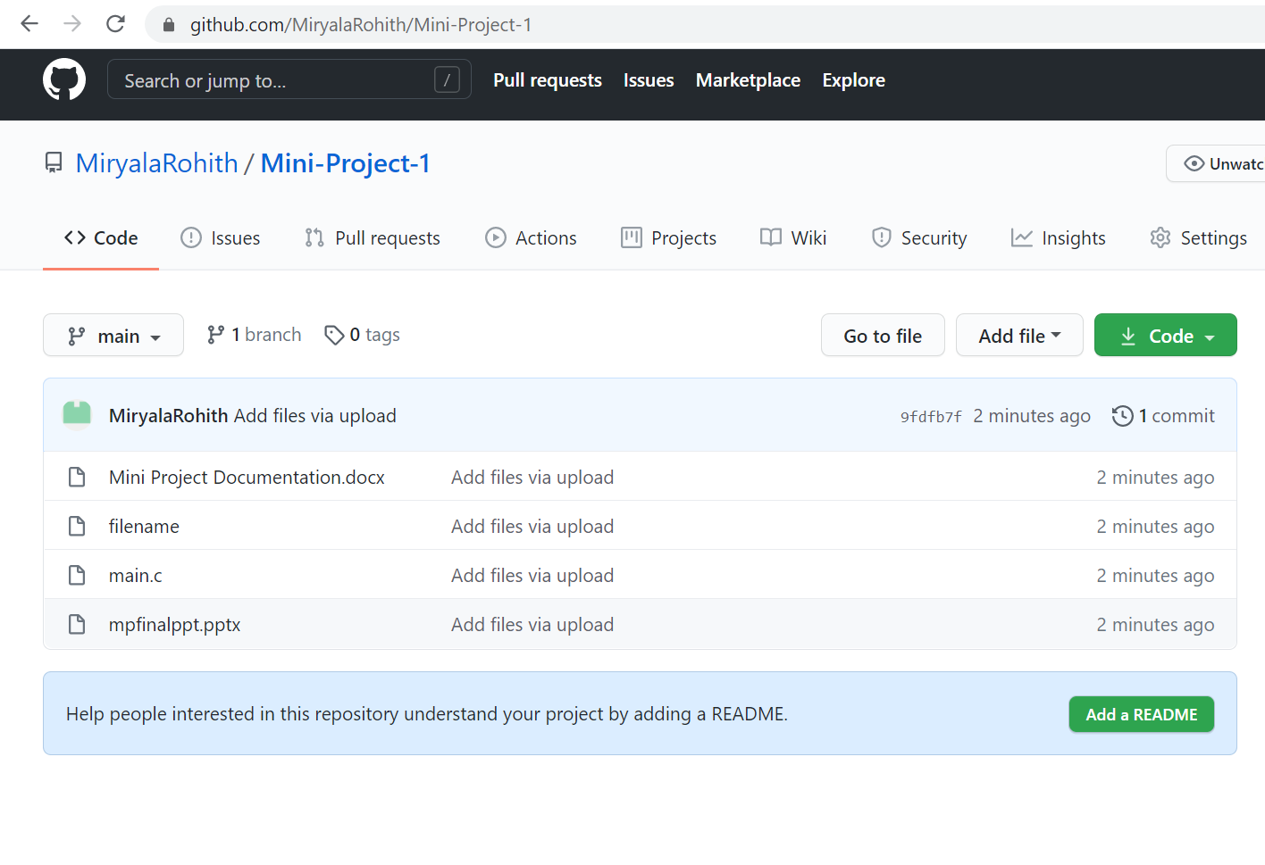

**3.3 Testing**

We approached testing our console application by analyzing each module separately. First, we coded the requirements and then manually tested each feature present in the module to cover any gaps that might occur.

First System user have to login with the predefined username and password. If the password and username are attempted incorrectly for thrice then it will exit and user will be out of the progarm. If the credentials were correct the System user get the access to COP’S FIR Management System Environment

Now a menu will be displayed with option 1 as add record, option 2 as search record, option 3 as modify record, option 4 as list record, option 5 as delete record finally option 6 will be exit.

If the user chooses the option 1 that is add record then he has to enter the name and unique identity number of convict if the UIN entered is already exists then it shows error if not the system allows the user to enter more details about convict like name, crime done ,conviction ,date of arrest e.t.c

If the user chooses the option 2 that is search record then he has to enter the name and UIN of the convict if the UIN entered is valid then system displays the record which exists for that particular UIN else displays no record exists.

If the user chooses the option 3 that is modify record then user has to enter the name and UIN of the convict whose record he wanted to modify then the system displays the previous data stored related to that UIN and list of credentials related to convict which he/she want to modify after choosing the option which needed to be modified the system asks for the new data for that particular credential after that the system displays the modified data as a new record and automatically saves the new data.

If the user chooses the option 4 that is list record then the system directly displays all the records which exists in the backend file.

If the user chooses the option 5 that is delete record then the system first asks the predefined password if it is valid then the system itself shows access granted to delete record and asks the user to enter the name and UIN of the convict whose record he/she wanted to delete and if the UIN is correct then only the record gets deleted in the backend .Incase if the entered UIN is incorrect then the data won’t be deleted in the backend but system displays deleted successfully such that if some unauthorized person want to delete the record without knowing UIN then he gets easily manipulated by the statements displayed in the console of the system. Also if the password entered is Invalid then the system directly terminates the program and user will be thrown out of the COP’S FIR Management System Environment.

If the user chooses the option 6 that is exit .The program terminates and user will be out of the COP’S FIR Management System Environment.

# 4.RESULTS

# 1.) 1.PNG2.PNG

# 2.)3.PNG

# 3.)4.PNG

# 4.)5.PNG

# 5.)6.PNG

# 6.)7.PNG

# 7.)8.PNG

# 8.)9.PNG

# 9.)10.PNG

# 10.)11.PNG

# 11.)12.PNG

# 5.What was the additional learning apart from the course programming for problem solving relate the ideas that you have gained implementing this mini-project

Implementing this project in C Language has introduced us to different libraries such as: ‘conio.h’, ‘stdlib.h’ . We were able to use the knowledge we have on the Linked List Data Structure and execute it as a real-time application. We explored the ‘conio.h’ libraries for achieving a look-and-feel of an actual window application.

Also, we have further improved in our knowledge in file-handling because of the vast amount of data manipulation we have done using text files.

# Other than this, we have learnt the value of team spirit and have understood the intention behind working in teams. We have learnt to be team players

# 6.CONCLUSION AND FUTURE WORK

# To conclude, this application is useful not only for legal institutions but

Also for any other organization who are keen to utilize this kind of application. It can be operated very easily.

Future work is to we develop the application in PHP Or HTML and to make this console application as a web application.

**7. REFERENCES**

1. C Language Documentation: [https://docs.microsoft.com/en-us/cpp/c- language/?view=msvc-160](https://docs.microsoft.com/en-us/cpp/c-language/?view=msvc-160)
2. Visual Studio (for debugging errors)
3. Stack Overflow (for debugging errors): <https://stackoverflow.com/>